To create and manage data import and export jobs, you use the Data management workspace. By default, the data import and export process create a staging table for each entity in the target database. Staging tables let you verify, cleanup, or convert data before you move it.
Once, within the data management work area, new projects can be created to export and import system information.
Export
Navigate to WorkSpaces > Data Management
Click on Export
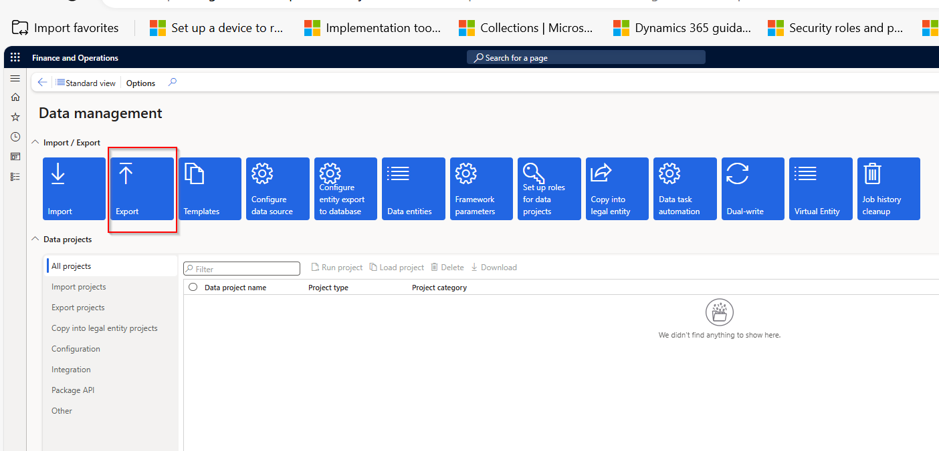

Fill in the fields “Group Name” and “Description” with the name of the project. i.e Vendor Export
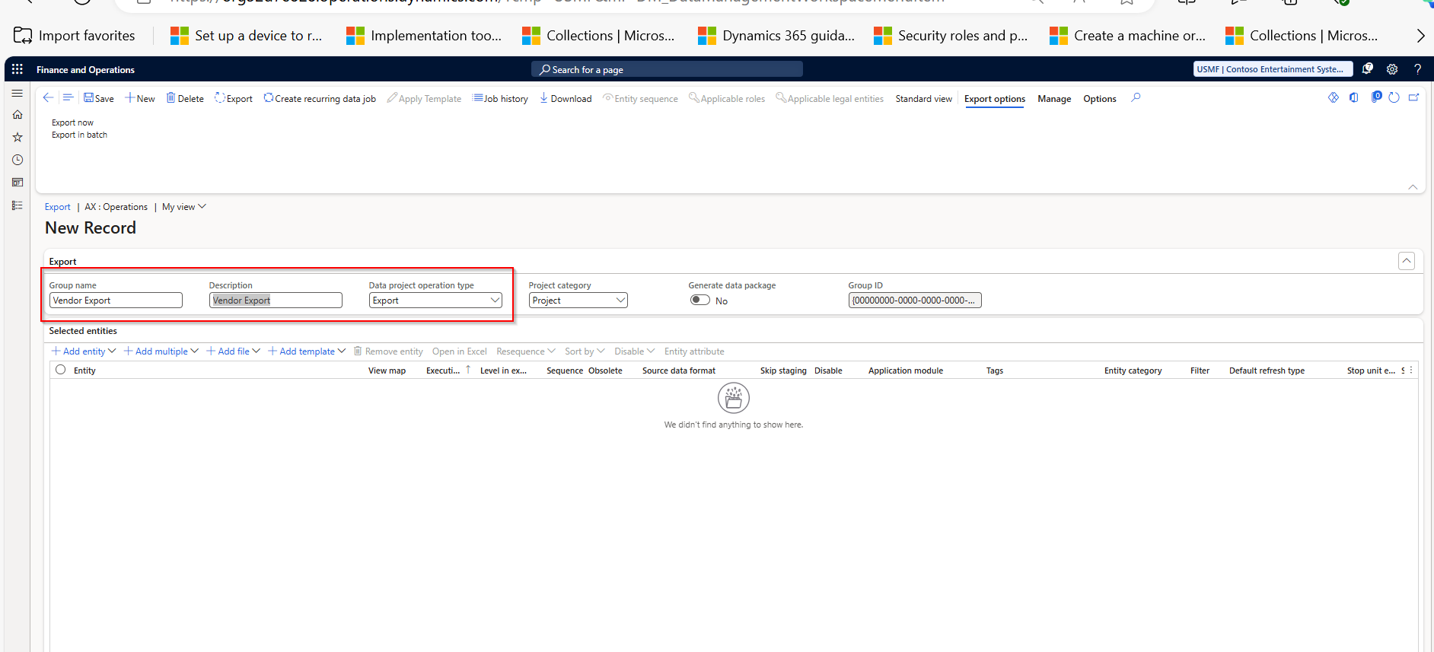
Click on "Add Entity" and first select the "Entity Name" that you want to export and then the "Target Data Format" selecting the format in which you want to export the system information.
Finally, click on “Add” to add the entity to the export list.
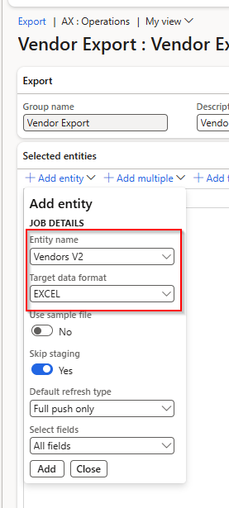

Once all the entities you need to export have been selected, click the export now button.
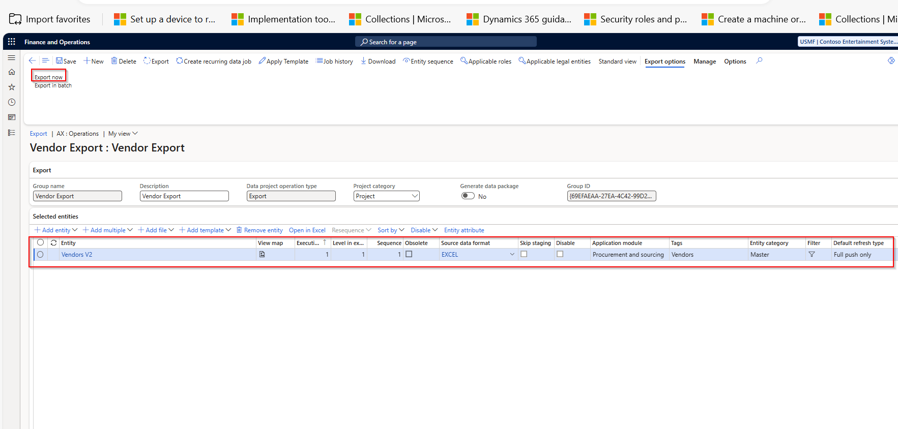

A new form will appear, click the refresh button until the status changes to " Succeeded". Once the export is complete, click “Download Package” or Download File to download the entities you just exported.
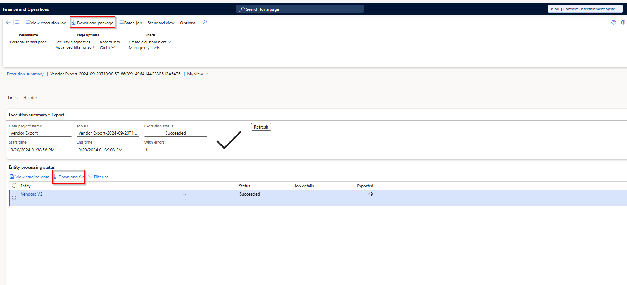

Import
Navigate to WorkSpaces > Data Management
Click on Import
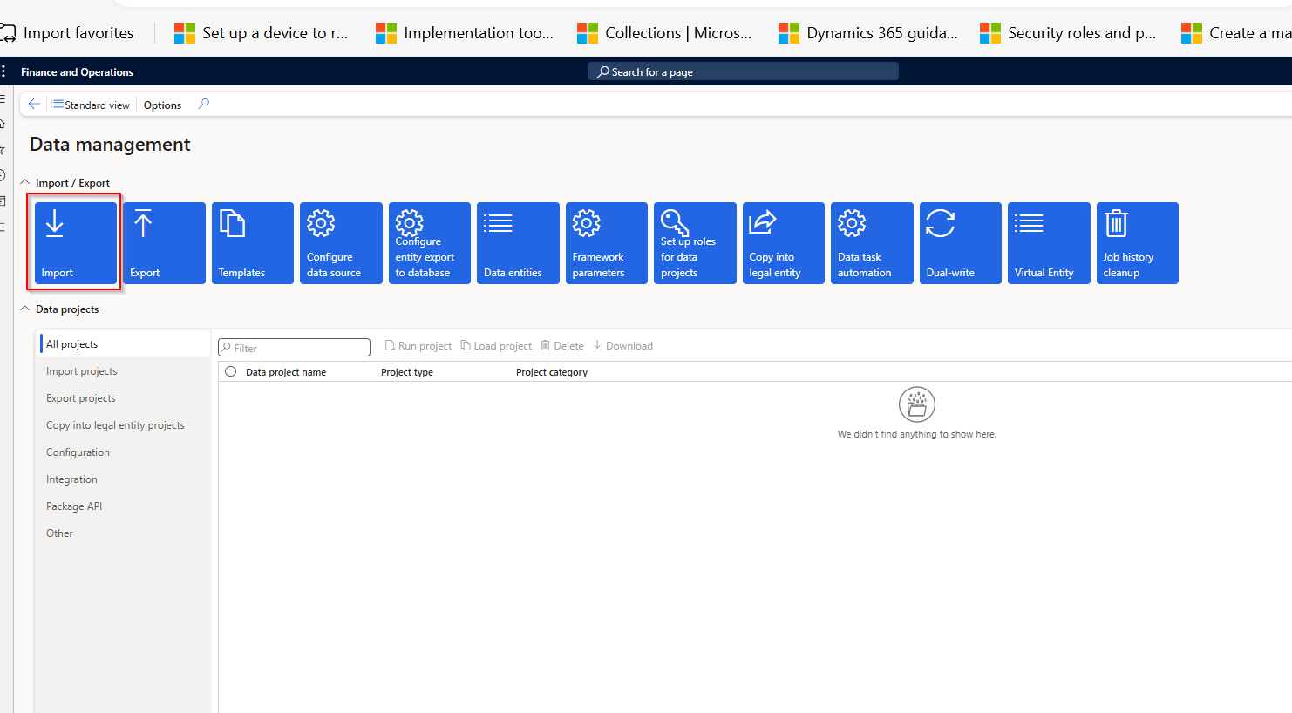

Create the new import project and fill in the “Group Name” and “Description” fields. i.e Vendor Import
Click on Add File
In Job details Source Data format Select Excel
In entity name Select Vendors V2
Click on Upload and add and select vendors file to upload.
Close all screens and Click on Import Now.
Refresh the next screen until Job is succeeded.
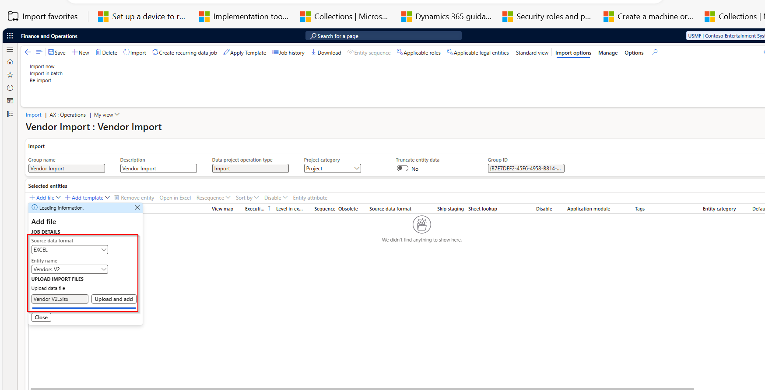

ADDITIONAL RESOURCES
https://learn.microsoft.com/en-us/dynamics365/fin-ops-core/fin-ops/data-entities/data-import-export-job

